Edit Fund Details Program Specifications for ABC Asset Management Fund Fact Sheet Generator
Project ID
Project Name | ABC Asset Management Fund Fact Sheet Generator
Account
Business Unit / Global Account
Project Manager
Document Version Number | 1.0.0
Approved by:

Revision History
Version Number | Release Date | Description of Change/s made | Author  (Name & Role) | Reviewer  (Name & Role) | Approver  (Name & Role)
 | Mmm-DD-YY

Table of Contents
Revision History 2
1. Program Description 4
1.1 Unit Name, Version and Language used 4
1.2 Unit Description 4
2. Input Specifications 4
2.1 Files/Tables 4
2.2 Screen Layouts 4
2.3 Parameters Passed 4
2.4 Validations 4
3. Process Specifications 4
3.1 Program structure chart 4
3.2 Pseudo code 4
4. Output Specification 5
4.1 Files/Tables 5
4.2 Screen Layouts 5
4.3 Report Layouts 5
4.4 Parameters Passed 5
4.5 Output formatting 5
5. Performance 5
6. Security 5
7. Reuse or Third-party component 6

Program Description

Unit Name, Version and Language used

Unit Name: Edit Fund Details
Language used: C#

Unit Description

The program unit will allow the user to edit various fund details.

Input Specifications

Files/Tables

companyInfo
Field Name | Data type | Size | Constraints | Remarks
fundTicker | Varchar | 50 | Primary Key
ISIN | Varchar | 50 | Foreign Key
status | Varchar | 50
companyName | Varchar | 50
sector | Varchar | 50
fixedHoldingRatio | Decimal | 18,0

Screen Layouts
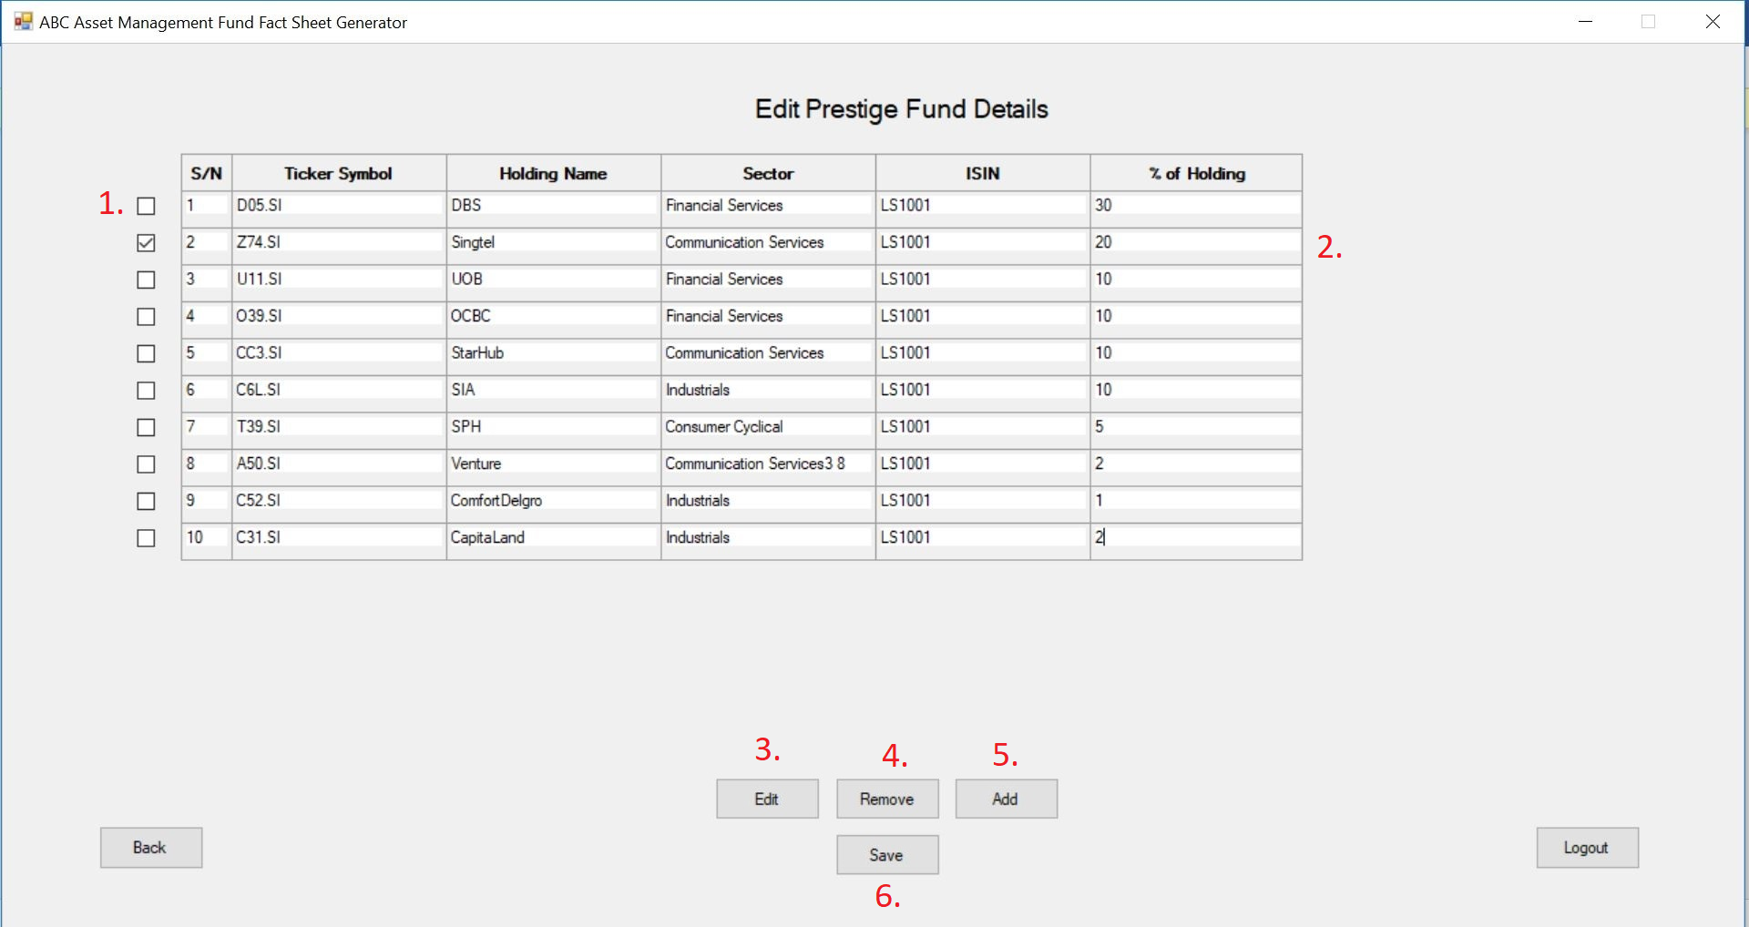

Parameters Passed
1. There will be checkboxes to indicate which fund to perform an action on.
2. The entries will be editable if the edit function is performed after selecting the desired rows. All entries will be editable except for the first column (S/N).
3. The edit button will allow the user to edit selected funds.
4. The remove button will allow the user to remove selected funds.
5. The add button will allow the user to add an empty row.

Validations.

6. The save button will allow the user to update and send the edited fund details to the database. If the total percentage holdings does not add up to 100%, there will be a pop up error message.

Process Specifications

Program structure chart

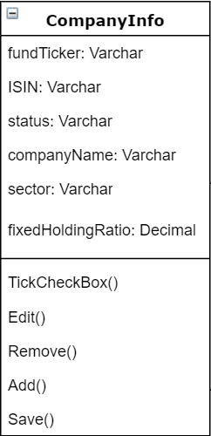

Pseudo code

TickCheckBox(n) {
CheckBox(n).Checked = True
}

Edit {
Foreach CheckBox in CheckBoxes
If (CheckBox.Checked == True)
CheckBox.Cells = Editable
}
Remove{
Foreach CheckBox in CheckBoxes
If (CheckBox.Checked == True)
Remove row(n)
}
Add{
Datatable.AddRow
}
Save{
Open SQL Connection
Update datatable
Close SQL
}

Output Specification

Files/Tables

companyInfo
Field Name | Data type | Size | Constraints | Remarks
fundTicker | Varchar | 50 | Primary Key
ISIN | Varchar | 50 | Foreign Key
status | Varchar | 50
companyName | Varchar | 50
sector | Varchar | 50
fixedHoldingRatio | Decimal | 18,0

Screen Layouts

Report Layouts

Parameters Passed
- fundTicker
- ISIN
- status
- companyName
- sector
- fixedHoldingRatio

Output formatting

Performance

Performance Requirements | Design | Constraints
Validation for % of holdings | The total percentage must add up to 100

Security

Application Areas | Identify special transactions and areas requiring Encryption
Application Data | Identify data that requires Encryption
Encryption in Transit/Storage | Identify need for Encryption while data transfer or storage
Encryption Policy | State the policy that governs Encryption

Reuse or Third-party component

External component | Module impacted | Assumptions and Constraints | Source/License

Template Revision History (For EPEX Use Only)
Version Number | Release Date | Description of Change/s made | Author  (Name & Role) | Reviewer  (Name & Role) | Approver  (Name & Role) | QMS Release Version
1.0 | NA | Initial baseline | NA | NA | SEPG | NA
2.0 | Jun-14-11 | Assigned artifact id, version #, release date to the template and modified Information Classification label in the footer | Shreevidhya Srinivasan, PM | Radhika Seenivasakan, SEPG | Rajesh Sreekumar, SEPG | 4.2
2.1 | Nov-30-18 | Modified SEPG references to EPEX as a part of Re-Org | Prakash Palaniswamy, EPEX | Pradeep Kumar Pullathil, HEAD, EPEX | Pradeep Kumar Pullathil, HEAD, EPEX | 7.5

